Launching
- Use the spare genoa or spinnaker halyard to hoist the dinghy over the lifeline.
- Lower the genoa sheet first for better access.
- When retrieving, close the forward hatches, turn the boat over gently. Don’t damage the lifelines, deck, hatches or the dinghy.
- To fit or remove the Yamaha motor, use a snatch-block fitted to the cockpit bimini rails and a rope to lower/retrieve the engine to/from the dinghy. Tie the safety line on first.
- Alternatively, you can use the main halyard and a winch to lower the motor but it snags a little over the bimini.

Notes:
- Generally, you should not tow the dinghy, certainly not with the outboard attached. It will flip over very easily losing the contents of the dinghy and flooding the motor.
- Don’t drag the fibreglass hull over sand or gravel or coral.
- Don’t allow the inflatable pontoons to be scratched or punctured under barnacle encrusted wharfs, etc.
- Fit the seat to the dinghy.
- Take the anchor and paddles. Tie the end of the anchor chain to the dinghy.
- Lifejackets are now compulsory in many jurisdictions.
- Try not to damage the inflated tubes by dropping the outboard motor leg onto it.
- Store the dinghy upside down, pointing forward over the forward hatch. Lashing it to the deck rings. Put the flat fender under the rowlocks to protect the deck.
- Boat must be stored with the UV stabilised cover if stored outside.
- Decrease the pressure of the boat by about one quarter when stored.
- Jib sheets will catch almost every tack. Rig a line from chest high on the mast to sides and forward of dinghy to help prevent the jib sheets from snagging.

Inflation
- Do not inflate or deflate one air chamber at a time. When inflating or deflating, maintain a balanced air pressure between air chambers to prevent stress or potential damage to the inside diaphragms that separate the air chambers.
- Unscrew the valve caps, turn a quarter of a turn counter clockwise. Make sure the valve stems are in the closed position. Push in on the valve stem and rotate to the closed position.
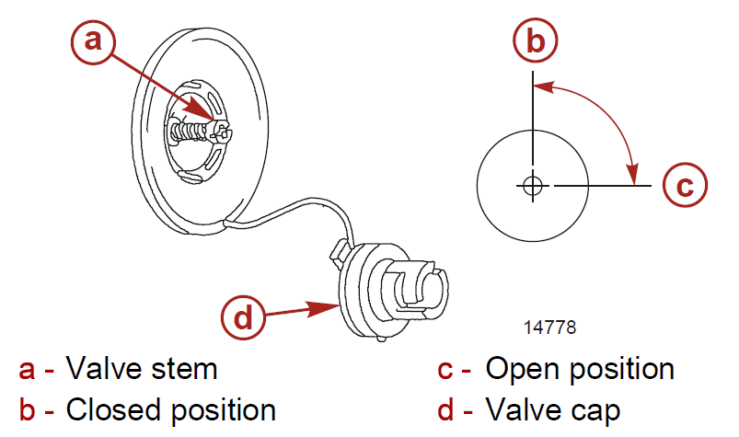
- Insert and lock the air pump fill adapter into the valve. Connect the air pump hose to the fill adapter.

- Pump is under bed in Stb aft cabin.
- Starting at one of the air valves, inflate each air chamber in turn inflating only a quarter of the way full. Repeat this procedure to evenly fill the air chambers until the air chambers are filled to the recommended air pressure of 0.24 bar (3.5 psi).
- As a gauge, you must be able to indent the tubes approximately 1.5 – 2.5 cm without a crease forming around your thumb.
- Be aware that as the air temperature increases the pressure in the tubes will also increase.
- You must monitor the pressure at all times and temperatures. Over inflation is not covered under warranty.
- Do not use an air compressor to inflate.

Deflation
- When deflating the side air chambers, do not deflate one side air chamber at a time. Maintain a balanced air pressure between air chambers to prevent stress or potential damage to the inside diaphragms that separate the air chambers.
- Unscrew the valve caps, turn a quarter turn counter clockwise.
- Push in the valve stem and deflate the keel. Push in the valve stem and turn the stem a quarter turn clockwise to lock the valve in the open position.
- Push in the valve stem and deflate the floor. Push in the valve stem and turn the stem a quarter turn clockwise to lock the valve in the open position.

Drain plug
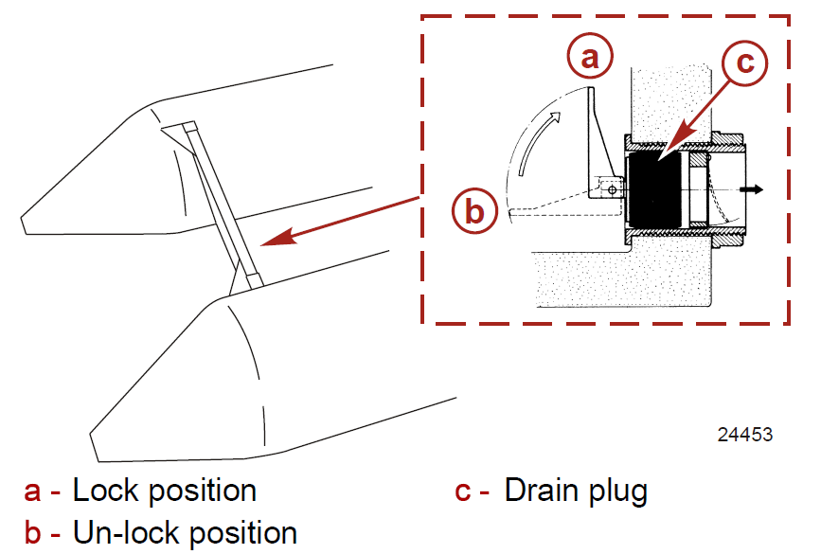
- When underway, remove the drain plug from the drain and the water will automatically run out. The inner diaphragm will prevent water from returning. After the water has been drained, replace the drain plug.

Yamaha Outboard motor
The Yamaha 5Hp outboard is a single cylinder, two valve, four stroke, water cooled motor.

Starting:
- Secure the motor to the inflatable using a rope lashing to the transom.
- Secure the fuel tank to the dinghy.
- Connect the fuel line and open the fuel tank breather
- Pump fuel line bulb until it is firm.
- If the motor is cold pull the choke out fully
- Set throttle at the start position
- Set the gear selector to neutral
- Give a few steady pulls on the starter rope. Warn passengers sitting behind you!
- When it starts push the choke in slowly, don’t throttle up too soon or it may stall and flood. The motor doesn’t need choke when it is warmed up.
- Before driving fit the safety cut out lanyard to your left wrist
- Check that cooling water is pumping out of the outboard leg.
- Let the engine revs settle to slow before selecting forward or reverse gear
- To stop the motor press the stop button in the control arm.

Fuel:
- The Yamaha outboard motor uses unleaded petrol.
- Leave the fuel tank breather open when being used during the day and in the sun. Otherwise the pressure in the tank can force fuel out of the fuel hose to motor fitting.
- The Yamaha motor has a fuel tap under the front of the motor

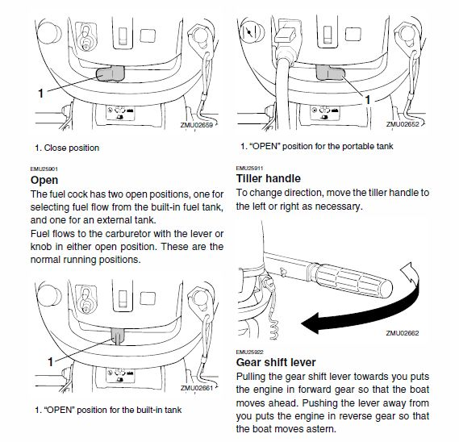

Flushing:
- The motor should be flushed with fresh water when possible. There is a flushing plug on the underside of the cowling and a rabbit ears flushing device.

